Assume you work for Google. Your team is responsible for currency answer, which means if a user types in currency related query (e.g., “usd to gel”) you are supposed to trigger the currency answer.

By triggering the answer, we mean that corresponding charts to the user must be displayed.

Example: 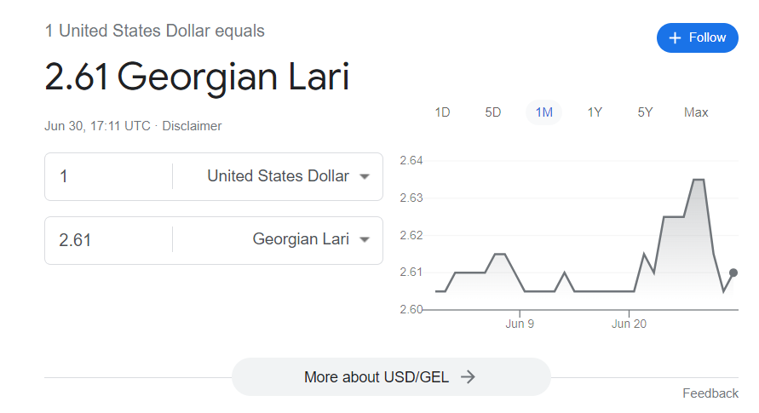

Your team has made some changes to the code base and now you are asked to do an analysis of the changes.

Your teammate scraped the queries from the web on a specific date range (2023-06-07_2023-06-07) for each of the markets. Then he provided 9 .txt files to you, each for a different market. (en-us is one example of market. En-us means that person from the usa searched for query in english language.)

Search engine uses two domains for triggering the answer:

1. CFG – deterministic model, which is context-free grammar. CFG gives confidence 1 when the query is recognized by the model. Otherwise, it gives ‘Null’; If CFG gives 1, then answer is recognized as currency intent query;

2. ML model – nondeterministic machine learning model, which gives the confidence of currency intent. We say the answer currency related if the confidence >= 0.85;

Your goal is to write all the queries to a file named “global.txt” where both CFG and ML model recognize the query as currency intent.

**Structure of the file:**

Each file consists of 3 tab seperated entries.

**Example**:

1550 pounds to euros 1 0.9373814

First column is query, second column is CFG confidence (‘Null’ if it’s not recognized), third column is ML model confidence.

Hint: you might find .split(‘\t’) useful to split the rows of the files by tab;